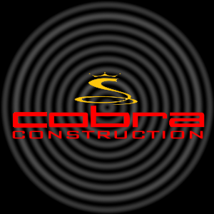
COBRA CONSTRUCTION
15997 Woodbine Circle
Vernon Hills, IL, 60061

Architecture Services

Stefan M Strauss Office: 888-4COBRA1
Architect Fax: 888-COBRA01
www.cobra.arc.com Pager: 888-11COBRA
:

